**SQL**

* Create User from **UI** https://dev-qwallity.herokuapp.com/.
* SELECT * FROM users
* WHERE username = ‘Tatevik Muradyan’;

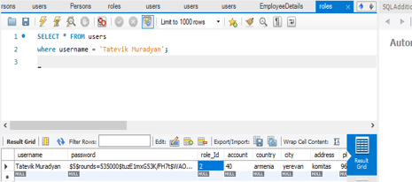

* Change user role in DB
* UPDATE users
* SET role_Id = ‘1’
* WHERE Id = ‘55555755’;

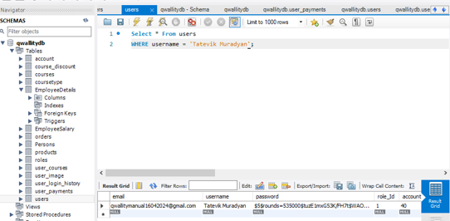

* Insert Course in database
* INSERT INTO courses (title, body, author, coursetype, price)
* VALUES ('English', 'text', 'Tatev', 1, 45);

• UPDATE courses

• SET date_created = now()

• WHERE id = 9001744;

|  |  |
| --- | --- |
|  |  |

* Update Course name
* UPDATE courses
* SET title = 'Armenian'
* WHERE id = 9001744;

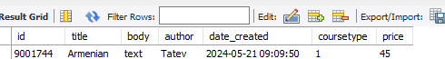

* Select all advanced courses
* SELECT * FROM courses
* WHERE coursetype = 2;

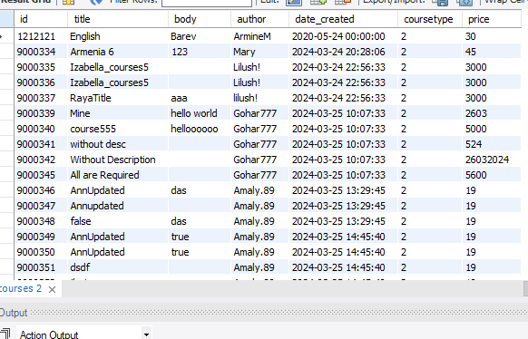

* Delete your added course
* DELETE FROM courses
* WHERE id = 9001744;

